Attachment 1
Types of Dehumidifiers subject to Recall
(Please visit product safety net for more information: http://safety.bsmi.gov.tw/)
Brands | Type no. | Manufactured dates | Contact information
TATUNG | TWD-510B | 2005.01~2006.10 | 1.Service hotline: 0800-052-666 Ext.3  2.Taoyuan air conditioner depot: 03-386-1111 Ext. 705  3.E-mail: showwen@tatung.com.tw
TATUNG | TWD-511B | 2005.01~2006.10
TATUNG | TWD-711B | 2005.01~2006.10
TATUNG | TWD-660B | 2005.01~2006.10
TATUNG | TWD-500B | 2003.01~2005.06
SANYO | SDH-501B | 2003.01~2005.06 | Service hotline：0800-081-567  E-mail: tsai@taizan.sanyo.com.tw
SANYO | SDH-512B | 2005.01~2006.10
SANYO | SDH-612B | 2005.01~2006.10
SANYO | SDH-680B | 2005.01~2006.10
TECO | MD1088B | 2003.01~2005.06 | Service hotline：0800-281-200 Ext.3  E-mail: arron.hsu@teco.com.tw
TECO | MD1095B | 2005.01~2006.10
TECO | MD1096B | 2005.01~2006.10
TECO | MD1097B | 2005.01~2006.10
TECO | MD1316B | 2005.01~2006.10
TECO | MD1401WA | 2005.01~2006.10
TECO | MD1801WA | 2005.01~2006.10
SAMPO | AD-K123 | 2005.01~2006.10 | Service hotline：0800-005-438 Ext.9  E-mail: nan@sampo.com.tw
SAMPO | AD-K125 | 2005.01~2006.10 | Service hotline：0800-005-438 Ext.9  E-mail: nan@sampo.com.tw
SAMPO | AD-1861N | 2005.01~2006.10 | Service hotline：0800-005-438 Ext.9  E-mail: nan@sampo.com.tw
WESTINGHOUSE | WED-112P | 2005.01~2006.10 | Service hotline：04-2491-2151  E-mail: mandy@kunitakara.com.tw
GIPSON | GD-102NB | 2003.01~2005.06 | Service hotline：0800-033-678  E-mail: yang@relon.com.tw
GIPSON | GD-105NBI | 2003.01~2005.06 | Service hotline：0800-033-678  E-mail: yang@relon.com.tw
FRIGIDAIRE | FDH-1020N | 2003.01~2005.06 | Service hotline：0800-033-678  E-mail: yang@relon.com.tw
FRIGIDAIRE | FDH-1050NBI | 2003.01~2005.06 | Service hotline：0800-033-678  E-mail: yang@relon.com.tw
KOLIN | KJ-K105B | 2003.01~2005.06 | Service hotline：0800-066-628 Ext.9  E-mail: 2ab@mail.kolin.com.tw or  r2s6@realise.com.tw
KOLIN | KJ-K50B | 2003.01~2005.06
WHIRLPOOL | ADS051M | 2003.01~2005.06 | Service hotline：0800-888-105  E-mail: ringo_hsu@whirlpool.com
Attachment 2
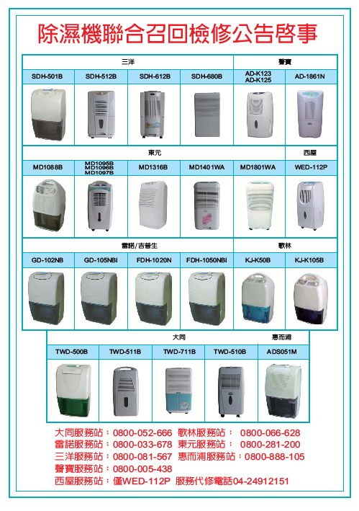

Joint Recall and Repair Notice for Dehumidifiers
SANYO
SAMPO
TECO
WESTINGHOUSE
GIPSON/FRIGIDAIRE
KOLIN
TATUNG
WHIRLPOOL
TATUNG: 0800-052-666 Ext.3 KOLIN：0800-066-628 Ext.9
TECO：0800-281-200 Ext.3 SANYO：0800-081-567
SAMPO：0800-005-438 Ext.9 WHIRLPOOL：0800-888-105
GIPSON/FRIGIDAIRE：0800-033-678
WESTINGHOUSE：04-2491-2151 (WED-112P only)

