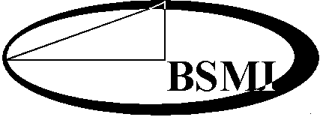
經 濟 部 標 準 檢 驗 局
附錄
THE BUREAU OF STANDARDS, METROLOGY AND INSPECTION
MINISTRY OF ECONOMIC AFFAIRS

商品驗證登錄授權放行通知書
Import Release Notice of Authorization for Registration of Product Certification

授權放行通知書號碼：
Import Release Notice of Authorization No.

茲同意被授權人於 年 月 日前得進口授權人已取得驗證登錄之商品(證書號碼： )，其相關事項如下：
The BSMI hereby agrees that the person specified below is authorized to import the following products, registered under the Registration of Product Certification Scheme (Certificate No. ) before the date of _____________. Details of the above authorization are described below.
被授權人：
Person being authorized
地址：
Address
統一編號：
Uniform No.
商品種類名稱
Type/name of the product
商品分類號列：
C.C.C. Code
中文名稱：
Chinese name
英文名稱：
English name
型 式：
Type
系列型式：
Series of the type

標準檢驗局或所屬分局核發
(本通知書必須加蓋鋼印後生效)
This notice shall be issued by the BSMI or its branches.
(This notice will become effective only when stamped with the BSMI seal.)

填發日期：中華民國 年 月 日
Date of issue (year) (month) (day)
CE-02 REV.3
附錄

