危害物質標誌圖例（參照CNS 15030）
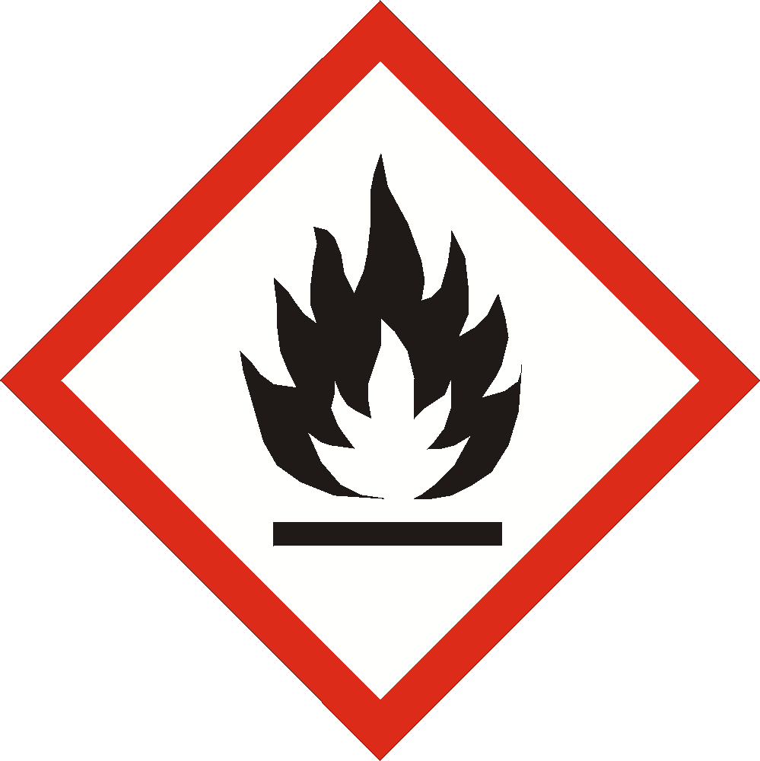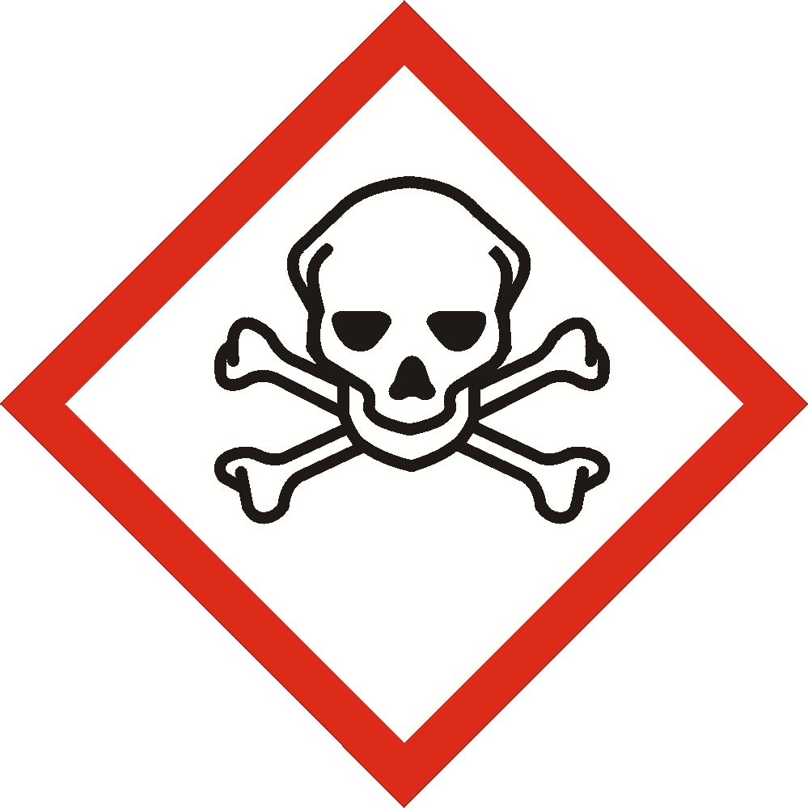
(易燃物質) (急毒性物質)

備註：GHS (Globally Harmonized System of Classification and Labelling of Chemicals)

